Template

TITLE

First author’s name and SURNAME, second author’s name and SURNAME

Abstract
Maximum length: 250 words
Keywords: 3-5 key words

1.

1.1.

2.

Tables: horizontal, centred, box, width: 1 pt.
Example:

Tabel n. Table title
Column 1 | Column 2 | Column 3 | Column 4 | Column 5
10 | 10 | 10 | 10 | 10

Figures: horizontal, centred, box, width: 1 pt.
Example:

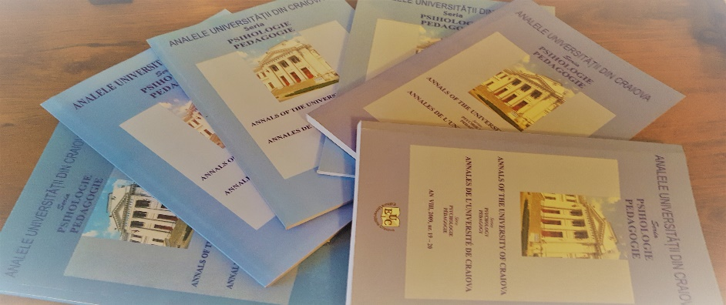

Figure no. 1. Title

REFERENCES
- Surname1, First letter of the first name 1. (coord.). (year). Title of the paper1. City: Publishing House.

Position, academic title, institutional affiliation, email address, corresponding author
Position, academic title, institutional affiliation, email address

