Dear contributors,

Number 1 (39) in the 2019 issue of Annals of Craiova Series Psychology, Pedagogy (ISSN 1582-313X), published by the Department of Teacher Training through Research Centre psych pedagogy (CCPP), proposes the theme Research Methodology in different fields of activity - from the fundamental scientific to the applied research.
Taking into account that research is an essential proof of the existence of a science, it is at the same time a condition of its evolution, of the progress of innovation, of the assurance / confirmation of the connection between the theoretical and the praxiological aspects.
Based on a problem, a structure, particular design, the research is built around a study topic carefully noted, new, even notable is based on the (re) interpretation, discussion, comparison, the clarification or an insight in a recurring problem.
Any reflection on this issue will present what is already known and used to propose new ways, new elements, methods that so far have not been used or used only a little with a view to demonstrating how they can make research advance in each field separately.
How to adapt the research methodology to every specific scientific field, how the different educational paradigm reflect on the research methodology, how to put to good use the various research tools be, how to disseminate research results so that they could be extended at the level of educational practice there are as many topics of reflection, possible questions . The answer lies in different research approaches, not only theoretical, applied and experimental, but also in monodisciplyinary, but also inter- and transdisciplinary approaches. These ideas that may stand as well for a "turmoil" for any researcher are found, expressed predominantly in a questioning manner in the topics proposed for this number:

1. Fundamental scientific research vs. Applied research
2. Research design or architecture or how to design a research
3. What is the specificity of the research methodology in the context of constructivist, humanistic or behavioural paradigms?
4. Quantitative methods vs. Qualitative research methods
5. Research Action - an essential means for optimising the educational practice
6. How can research results be exploited, disseminated?
7. The specificity of the research paths, analysis approaches, ways of structuring argumentation, body structure , etc. in humanistic and social sciences
8. The actors of research, the actors of innovation : positioning, relationships, strategies, speech.

Keywords: Pedagogical Research ; Fundamental scientific research; Applied research; Quantitative research methods; Qualitative research methods; Design of research; Action research; Innovation Actors.
The evaluation of the studies shall take into account the following aspects: the research perspective; the novelty of the issues addressed and the way of its theoretical substantiation; research design; research methodology; results are obtained; the relevance of discussions and interpretations; consistency of conclusions; the relevance and timeliness of the bibliography.
Your proposals will be organised in several sections of the magazine: Theoretical Approaches - Re-evaluations and Openings; Educational practice - new perspectives; Research Laboratory ; Current - Computer-assisted training; From Comparative History and Pedagogy of Teacher Training; Books and Ideas and a Varia Section.

Editors in chief: Associate Professor Florentina MOGONEA, PhD, University of Craiova, Associate Professor Alexandrina Mihaela POPESCU, PhD, University of Craiova.

Coordinators of the thematic number:
Jean-Marc DEFAYS, University of Liège, Belgique, Florentina MOGONEA, Associate Professor PhD, University of Craiova, Romania, Alexandrina Mihaela POPESCU, Associate Professor PhD, University of Craiova, Romania, Cecilia CONDEI, Professor PhD, University of Craiova, Romania.

Editors: Associate Professor Florentin-Remus MOGONEA PhD, Associate Professor Ecaterina Sarah FRĂSINEANU PhD, Associate Professor Vali ILIE PhD, Associate Professor Mihaela Aurelia ŞTEFAN PhD, Associate Professor Aurel PERA PhD, Senior Lecturer Emil LAZĂR PhD, Senior Lecturer Răzvan-Alexandru CĂLIN PhD, Junior Lecturer Oprea Valentin BUŞU PhD.

Editorial board:
- Cecilia CONDEI, Professeur des universités, HDR, Université de Craiova, Roumanie
- Sigolène COUCHOT-SCHIEX, Maître de conférences, HDR, LIRTES EA 7313, Université Paris-Est, Créteil, France
- Euphrosyne EFTHIMIADOU, Professeure Associée à l’École de l’Air hellénique, Base Aérienne de Dekeleia, Grèce
- Caroline GOSSIEAUX, Responsable de formation, Université de Pau et des Pays de l’Adour, France
- Miron IONESCU, Professor PhD, Babeş-Bolyai University of Cluj-Napoca, Romania
- Aoife LEAHY, PhD, Independent Researcher, Editor ESSE Messenger, Dublin, Ireland
- Monique LEBRUN-BROSSARD, Professeure émérite, HDR, Université du Québec à Montréal, Canada
- Agnès LEROUX-BÉAL, Maître de conférences, HDR, UFR LCE, Université de Paris Nanterre
- Marin MANOLESCU, Professor PhD, University of Bucharest, Romania
- Deborah MEUNIER, Chargée de cours, Université de Liège, Belgique
- Ioan NEACŞU, Professor PhD, University of Bucharest, Romania
- Armela PANAJOTI, Associate Professor, PhD, “Ismail Qemali” University of Vlora, Albania
- Sofia Loredana TUDOR, Associate Professor PhD, University of Pitesti, Romania
- Titela VÎLCEANU, Associate Professor PhD, University of Craiova, Romania
- Ana VUJOVIĆ, Professeure des universités, Faculté de Formation des maîtres, Université de Belgrade, Serbie

Technical Details:
Paper length: 10 - 15 pages, in MS Word; reviews, conference reports, reading notes: 2-4 pages. The texts shall be fully written in English or French, accompanied by an Abstract and by Keywords in English.
The papers will be evaluated by 2 independent reviewers, in the blind Peer-Review system. An author can contribute up to two papers, provided they fit into different sections of the volume. We only accept studies where the maximum number of authors is 2. In this case, the contact author shall be indicated.

Text formatting - top: 2 cm, bottom: 2 cm, left: 2 cm, right: 2 cm, heading: 2 cm, footing: 0 cm, page size: B5 (17 cm x 24 cm), Times New Roman, 11 pt, spacing - single 1 (please see the Annex). Citations of bibliography and webography shall be done in accordance the APA Publication Manual (American Psychological Association), the 6th edition.
An Abstract of maximum 250 words and 3-5 key words (in English) shall be provided alongside the paper.
We are looking forward to your manuscripts on the mail ad auc.pp.dppd@gmail.com up to May 1, 2019 publication of the volume will be carried out until June 30, 2019.
For more information, please see the journal`s web page: http://aucpp.ro/

Editors in chief,
Associate Professor Florentina MOGONEA, PhD
Associate Professor Alexandrina Mihaela POPESCU, PhD

Template

TITLE

First author’s name and SURNAME, second author’s name and SURNAME

Abstract
Maximum length: 250 words
Keywords: 3-5 key words

1.

1.1.

2.

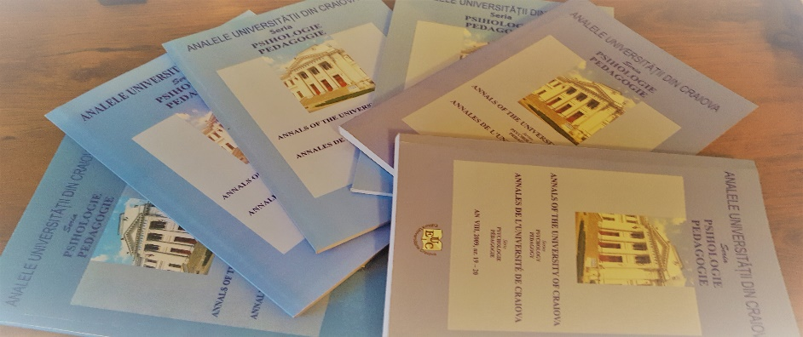

Figure no. 1. Title

Tables: horizontal, centred, box, width: 1 pt.
Example:

Tabel n. Table title
Column 1 | Column 2 | Column 3 | Column 4 | Column 5
10 | 10 | 10 | 10 | 10

REFERENCES
- Surname1, First letter of the first name 1. (coord.). (year). Title of the paper1. City: Publishing House.

Position, academic title, institutional affiliation, email address, corresponding author
Position, academic title, institutional affiliation, email address

